# Exercise: Semantic HTML

This document defines an in-class exercise from the Web Fundamentals (HTML & CSS).

## Refactor HTML

You’ll be given an HTML page with some legacy tags. Your task is to refactor the HTML code using semantic tags like <header>, <main>, <aside>, <nav>, <footer> and etc.

### Step 1: Wrapper

Create a div with id “wrapper” which holds the whole page content.

### Step 2: Add all page content in “wrapper”

Take all content and add it in the “wrapper”.

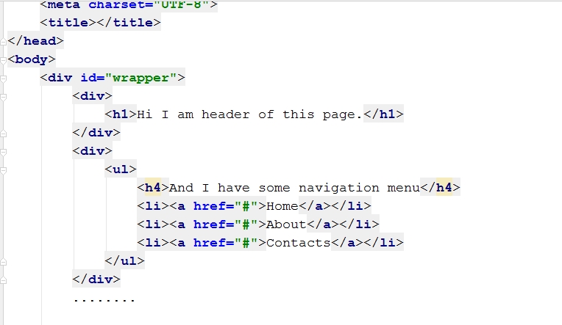

### Step 3: Refactor all div tags.

Replace all div tags with appropriate semantic tag.